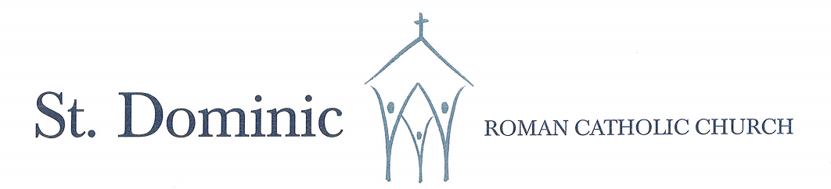
A Faith Community Alive in Christ Jesus
625 Atwater Avenue, Mississauga, Ontario L5G 2A8 Ph: 905-278-7762 = Email:stdominicsmi@archtoronto.org

Confirmation Registration Form – Page 1 of 3

Please complete this form and return it to the parish (PLEASE PRINT)
Parish Information
Name of Parish: _______________________________________________________________________________________
I currently live within the territorial boundaries of the parish.
I currently do not live within the territorial boundaries of the parish, but I am formally registered at the parish.

Candidate’s Information
Candidate’s Full Legal Name:

First Name Middle Name(s) Last Name
Male Female Date of Birth:_________________________ City of Birth:_____________________________________
Church of Baptism: _____________________________________________________Date of Baptism:___________________________
Address of Baptismal Church: ______________________________________________________________________________________

Please attach a PHOTOCOPY of your child’s baptism certificate (even if your child was baptized at St. Dominic’s Parish)
Your child has received the sacraments of First Reconciliation and First Communion

CANDIDATES SCHOOL: ___________________________________________________________________________________________
CANDIDATES GRADE: GR.7 GR.8 OTHER
Parent’s Information
Father’s First & Last Name: ___________________________________________________________________________

Religion: Roman Catholic Other:___________________________________________________________ None________
Present Address: _______________________________________________________________________________________________
Phone: ___________________________________________________ Email: _______________________________________________
I am a parent of or have legal custody of the child.

Confirmation Registration Form – Page 2 of 3

Mother’s Full Legal Name:

_______________________________________________________________________________ First Name Middle Name(s) Last Name

Religion: Roman Catholic Other:___________________________________________________________ None________

Present Address: _______________________________________________________________________________________________
Phone: ___________________________________________________ Email: _______________________________________________
- I am a parent of or have legal custody of the child.
____________________________________________________________________________________________________
Preferred email for communication: ___________________________________________________
All emails will be sent to above email

Eligibility of Sponsor
Canon 892 Insofar as possible, there is to be a godparent for the person to be confirmed; the godparent is to take care that the confirmed person behaves as a true witness of Christ and faithfully fulfills the obligations inherent in this sacrament.
Canon 893 §1 To perform the function of Sponsor, a person must fulfill the conditions mentioned in canon 874 (see below).
The following are the requirements in order for a Catholic to be a Sponsor (canon 874 §1):
- at least 16 years of age
- he/she has been fully initiated in the Catholic Church (received Baptism, Holy Communion, and Confirmation)
in good standing with the Catholic Church: live a life of faith which befits the role to be undertaken; not under canonical penalty
- not the father or mother of the one to be confirmed

Sponsor’s First & Last Name:

Age:_________ Current Parish:_____________________________Address:______________________________________
Present Address: _____________________________________________________________________________________
Phone: _________________________________________ Email: _______________________________________________
Fulfills the requirement of canon 874

Confirmation Registration Form – Page 3 of 3
The Registration fee is $70.
REGISTRATION PAYMENT METHODS:
CASH DROPPED AT PARISH OFFICE: _________________________
E-TRANSFER TO TDIAS@ARCHTORONTO.ORG __________ PASSWORD: “Confirmation”
(PLEASE ENTER YOUR CHILDS FIRST AND LAST NAME IN COMMENTS OF E-TRANSFER)

Declaration
BY SIGNING BELOW, I AGREE TO SUPPORT MY CHILD’S SPIRITUAL DEVELOPMENT BY ACCOMPANYING HIM/HER TO SUNDAY MASS. I FURTHER AGREE THAT THE SPONSOR WE HAVE CHOSEN MEETS THE ELIGIBLE CRITERIA AS OUTLINED IN CANON LAW.

I, the undersigned, declare that the information on this form (Pages 1 -3) is true and accurate.

PLEASE PRINT NAME: _______________________________________________________________________
Signature: _________________________________________________Date: ____________________________

If you have concerns about any of the requirements, please contact the parish office.
Please note that registration forms with cash payments are to be dropped off in the Parish office (please check our office hours) Bring the copy of the Baptismal certificate and the form to the church office or email to stdominicsmi@archtoronto.org.
If your child has NOT been baptised into the Catholic Faith and/ or received First Holy Communion you can still register your child but they must be baptized and receive first holy communion before being confirmed. Please contact our Baptism Coordinator by email at stdominicsmi@archtoronto.org.

