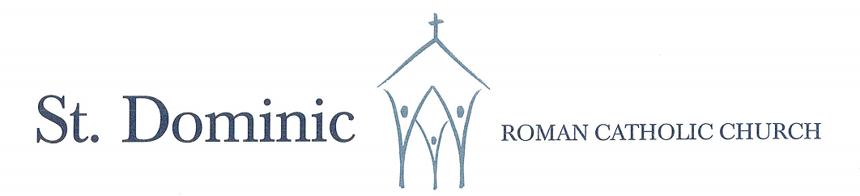
A Faith Community Alive in Christ Jesus
625 Atwater Avenue, Mississauga, Ontario L5G 2A8 Ph: 905-278-7762 = Email:stdominicsmi@archtoronto.org

First Holy Communion Registration Form– Page 1 of 2

Please complete this form and return it to the parish (PLEASE PRINT)
Parish Information
Name of Parish: _______________________________________________________________________________________
I currently live within the territorial boundaries of the parish.
I currently do not live within the territorial boundaries of the parish, but I am formally registered at the parish.

Child’s Information
Child’s Full Legal Name:

First Name Middle Name(s) Last Name
Male Female Date of Birth:_________________________ City of Birth:_____________________________________
Church of Baptism: _____________________________________________________Date of Baptism:___________________________
Address of Baptismal Church: ______________________________________________________________________________________
Child’s School: St. Dominic Catholic Elementary School Queen of Heaven Catholic Elementary School
Other – Please Specify __________________________________ Grade: Gr. 2 Other – Please Specify ________
Parent’s Information
Father’s First & Last Name: _____________________________________________________________________________
Religion: Roman Catholic Other:___________________________________________________________ None_________
Present Address: _______________________________________________________________________________________________
Phone: ___________________________________________________ Email: _______________________________________________
I am a parent of or have legal custody of the child.
Mother’s First & MAIDEN Name: ________________________________________________________________________
Religion: Roman Catholic Other:___________________________________________________________ None________
Present Address: _______________________________________________________________________________________________
Phone: ___________________________________________________ Email: _______________________________________________
I am a parent of or have legal custody of the child.

→

The Registration fee is $50.
REGISTRATION PAYMENT METHODS:
CASH: _________________________
E-TRANSFER TO TDIAS@ARCHTORONTO.ORG __________
(PLEASE ENTER YOUR CHILDS FIRST AND LAST NAME IN COMMENTS OF E-TRANSFER)

Declaration
BY SIGNING BELOW, I AGREE TO SUPPORT MY CHILD’S SPIRITUAL DEVELOPMENT BY ACCOMPANYING HIM/HER TO SUNDAY MASS.

I, the undersigned, declare that the information on this form (Pages 1 & 2) is true and accurate.

PLEASE PRINT NAME: _______________________________________________________________________
Signature: _________________________________________________Date: ____________________________

First Holy Communion Registration Form – Page 2 of 2

